GRAPHENE-METAL OXIDE COMPOSITE FILM FOR RF SHIELDING01
Lightweight 50 MHz RF Isolation Solution for Carbon Fiber Housing
Saturday, July 11, 2026
Document ID | RF-SHIELD-GMO-001
Revision | Rev. A — Draft for Review
Date | 2026-07-10
Classification | Engineering Technical Document

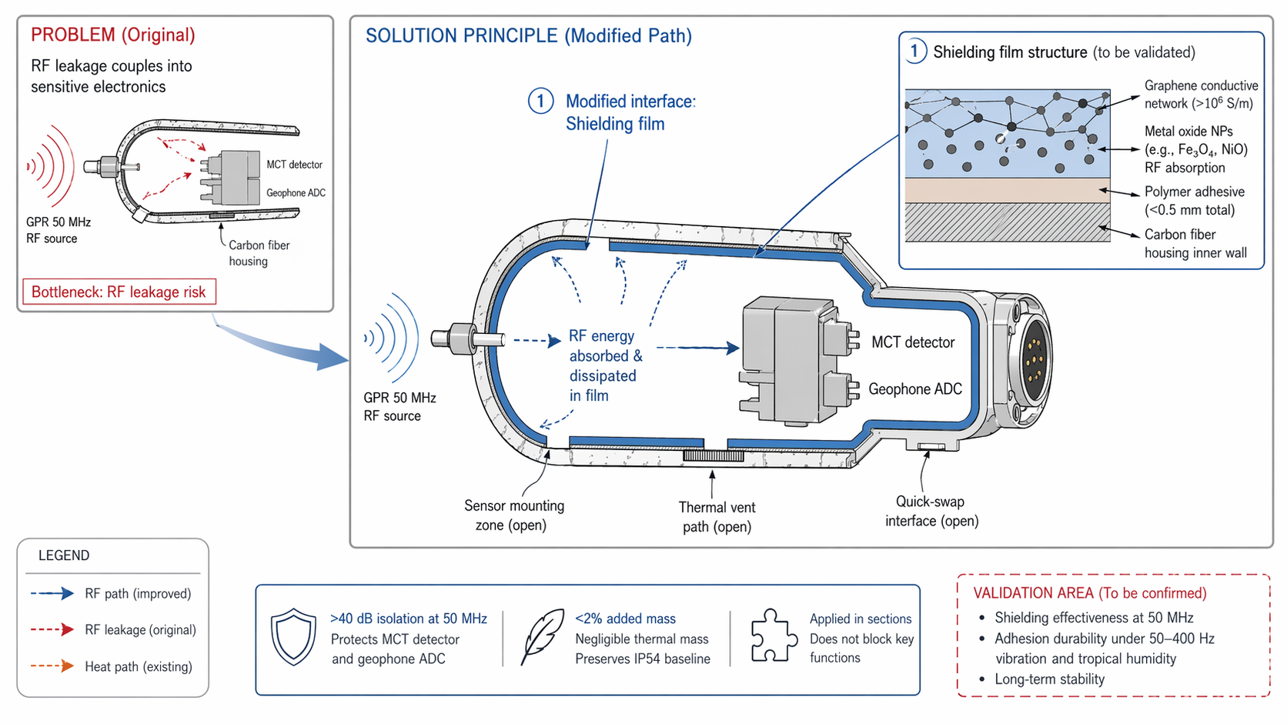

1. EXECUTIVE SUMMARY
This document presents a graphene-metal oxide composite film solution designed to provide >40 dB RF isolation at 50 MHz for a lightweight carbon fiber sensor housing. The composite film—comprising a high-conductivity graphene conductive network (>10⁶ S/m) with anchored metal oxide nanoparticles (Fe₃O₄, NiO) for RF absorption—is laminated to the interior surface using a polymer adhesive, achieving a total thickness under 0.5 mm and a mass budget below 0.2 kg (<2% of pod total mass). This approach eliminates the mass penalty associated with continuous metal liners while preserving the housing's IP54 thermal management baseline and structural integrity.

2. PROBLEM STATEMENT
The existing carbon fiber composite housing provides inadequate electromagnetic shielding at 50 MHz, the operating frequency of the Ground-Penetrating Radar (GPR) system. Unattenuated RF leakage penetrates the enclosure and couples into sensitive subsystems:
- MCT (Mercury Cadmium Telluride) Detector — susceptible to noise-induced drift and reduced signal-to-noise ratio.
- Geophone ADC — analog-to-digital conversion accuracy degraded by conducted and radiated EMI.
- Target isolation requirement: >40 dB to ensure operational integrity in high-RF environments.
Traditional solutions (e.g., continuous aluminum or copper liners) add significant mass, compromise thermal venting, and increase manufacturing complexity. A lightweight, conformal composite film alternative is required.

3. SOLUTION ARCHITECTURE

3.1 Graphene-Metal Oxide Composite Film Structure
The proposed solution laminates a multi-functional composite film to the interior surface of the carbon fiber housing. The film integrates two synergistic material systems: a graphene conductive network for electromagnetic reflection/shielding and metal oxide nanoparticles for dielectric loss and RF absorption.
Layer | Material | Thickness | Function
Substrate | Carbon Fiber Composite | — | Structural housing, interior surface
Adhesive Layer | Polymer adhesive (e.g., epoxy or PU) | <0.1 mm | Bonding interface, mechanical adhesion to carbon fiber
Graphene Conductive Network | Graphene sheets / CVD graphene film | ~0.2–0.3 mm | High-conductivity path (>10⁶ S/m); primary EM reflection / conduction
Metal Oxide Nanoparticles | Fe₃O₄ (magnetite) / NiO (nickel oxide) NPs | Dispersed within graphene matrix | Dielectric loss / magnetic loss; RF energy absorption at 50 MHz
Protective Overcoat | Thin polymer encapsulant (optional) | <0.05 mm | Environmental protection, abrasion resistance
Total film thickness: <0.5 mm | Total added mass: <0.2 kg (<2% of pod mass)

3.2 RF Shielding Mechanism
At 50 MHz, the composite film operates via a dual-mode shielding mechanism that leverages both the conductive graphene network and the lossy metal oxide nanoparticles:
Reflection Loss (Graphene Network): The graphene conductive network (>10⁶ S/m) provides a low-impedance surface that reflects incident RF energy. At 50 MHz, the skin depth in graphene is approximately 2–5 µm, well within the film thickness, ensuring effective surface current conduction and reflection coefficient Γ > 0.99. The high aspect ratio of graphene sheets creates a percolated conductive path with minimal filler loading.
Absorption Loss (Metal Oxide Nanoparticles): Anchored Fe₃O₄ and NiO nanoparticles introduce magnetic and dielectric losses at 50 MHz. Fe₃O₄ exhibits natural ferromagnetic resonance in the MHz range, converting RF energy to heat via hysteresis and domain-wall relaxation. NiO contributes dielectric polarization loss. The nanoparticles are dispersed within the graphene matrix, ensuring uniform loss distribution and preventing re-radiation of absorbed energy.
Synergistic Effect: The combination of reflection (graphene) and absorption (metal oxides) achieves broadband shielding effectiveness. Multiple internal reflections at graphene–oxide interfaces further enhance attenuation through interference effects, analogous to a distributed transmission-line absorber.

4. APPLICATION PROCESS

4.1 Surface Preparation
Adhesion and long-term durability of the composite film depend critically on substrate preparation. The following steps are performed prior to lamination:
Step 1: Cleaning & Degreasing — Remove mold release agents, oils, and particulate contaminants using isopropyl alcohol or approved solvent wipe. Allow to dry completely.
Step 2: Surface Activation — Optionally plasma-treat or corona-treat the carbon fiber surface to increase surface energy (>40 mN/m) and promote adhesive wetting.
Step 3: Masking — Protect sensor mount zones, thermal vent paths, and quick-swap interface areas with precision-cut masking tape or removable plugs. Define film section boundaries.

4.2 Film Lamination Process
The composite film is applied in pre-cut sections to conform to the interior geometry of the carbon fiber housing. Process parameters:
Parameter | Specification
Film Format | Pre-cut sections from roll stock; tailored to housing interior CAD geometry
Adhesive Type | Pressure-sensitive acrylic or heat-activated epoxy film adhesive
Application Pressure | 0.5–2.0 bar (roller or vacuum bag)
Cure Temperature | Ambient to 80 °C (depending on adhesive chemistry)
Cure Time | 24 h ambient or 2 h at 60 °C
Overlap Joints | 5–10 mm overlap between adjacent film sections to ensure electrical continuity
Sectioning Strategy | Applied in sections to avoid obstructing sensor mounts, thermal vents, and quick-swap interfaces
Electrical continuity between sections verified by 4-point probe or multimeter (<1 Ω resistance across joints).

5. DESIGN CONSTRAINTS & CLEARANCES
The film is applied in sections to the interior surface and is engineered to preserve all functional clearances:
• Sensor Mount Zones: Left clear of film to ensure electrical and thermal interface integrity with MCT detector and geophone ADC modules.
• Thermal Vent Paths: Unobstructed to maintain convective cooling performance and IP54-rated thermal management baseline.
• Quick-Swap Interface: Exposed for tool-less module exchange; film terminated with a 3 mm margin from interface edges.
• Mass Budget: <0.2 kg total added mass (<2% of pod total mass).
• Thermal Mass: Negligible increase; film specific heat capacity and thickness do not alter thermal time constants.
• Film Thickness: <0.5 mm total to avoid interference with internal component clearances.

6. PERFORMANCE SPECIFICATIONS
Parameter | Target | Verification Method
RF Isolation | >40 dB @ 50 MHz | MIL-STD-285 / IEEE 299 shielding effectiveness test
Total Film Thickness | <0.5 mm | Micrometer or caliper measurement
Added Mass | <0.2 kg (<2% of pod mass) | Precision balance (±1 g resolution)
Graphene Conductivity | >10⁶ S/m | 4-point probe measurement per ASTM D4496
Adhesion Strength | >5B (ASTM D3359) or >2 MPa peel strength | Cross-hatch tape test / 90° peel test
Operating Temperature | -20 °C to +60 °C | Environmental chamber cycling

7. VALIDATION & TEST PLAN

7.1 Prototype Testing — Shielding Effectiveness
Shielding effectiveness (SE) shall be measured per MIL-STD-285 or IEEE 299 using a dual-chamber method. A 50 MHz CW signal is injected into the source chamber; field strength is measured in the receive chamber with and without the laminated housing panel installed. SE is calculated as:
SE (dB) = 20 log₁₀(E_without / E_with)
Acceptance criterion: SE > 40 dB at 50 MHz across all housing surfaces, including section overlap joints.

7.2 Environmental Durability Testing
Long-term shielding stability under operational and storage conditions requires accelerated life testing. The following test matrix is proposed:
Test | Condition | Duration | Acceptance Criteria
Vibration Durability | 50–400 Hz, 5–20 g RMS random | Per axis, 8 h minimum | No delamination, cracking, or >3 dB shielding degradation
Tropical Humidity | 40 °C / 95% RH | 500 h (IEC 60068-2-78) | No corrosion, blistering, or >3 dB shielding degradation
Thermal Cycling | -20 °C ↔ +60 °C | 100 cycles | No delamination or adhesion loss; shielding stable

7.3 Long-Term Stability Assessment
Accelerated aging tests (85 °C / 85% RH for 1000 h per JESD22-A101) shall be performed on coupon samples to evaluate conductivity retention, adhesion degradation, and nanoparticle migration. Post-test characterization includes: 4-point probe conductivity, SEM/EDS of nanoparticle distribution, and peel strength per ASTM D1876.

8. RISK ASSESSMENT
Risk | Likelihood | Impact | Mitigation
Delamination under vibration | Medium | High | Optimized adhesive selection + surface activation; qualification vibration test
Graphene conductivity degradation in humidity | Low | High | Protective polymer overcoat; hydrophobic graphene functionalization
Nanoparticle agglomeration affecting uniformity | Medium | Medium | Controlled dispersion process; sonication + surfactant stabilization
Adhesive outgassing in vacuum/thermal cycling | Low | Medium | Low-outgassing adhesive per ASTM E595; bake-out prior to assembly
Section joint electrical discontinuity | Medium | Medium | Overlap design + conductive adhesive at joints; in-process resistance check

9. CROSS-DOMAIN INTEGRATION
This solution bridges nanomaterials science, electromagnetics, polymer chemistry, and manufacturing engineering:
Nanomaterials Science: Graphene synthesis (CVD or liquid-phase exfoliation) and metal oxide nanoparticle synthesis (co-precipitation, sol-gel) optimized for conductivity and magnetic/dielectric loss at 50 MHz.
Electromagnetics: Finite-element modeling (COMSOL, CST Studio Suite) of composite film shielding effectiveness, accounting for frequency-dependent permittivity and permeability of Fe₃O₄/NiO.
Polymer Chemistry: Adhesive formulation balancing peel strength, thermal stability, and outgassing requirements; compatibility with graphene and carbon fiber surfaces.
Manufacturing Engineering: Roll-to-roll film production, die-cutting, and robotic lamination adapted from flexible electronics and aerospace composite manufacturing.
Systems Engineering: Mass, thermal, and structural budgets reconciled with RF performance requirements; traceability matrix maintained from requirement to verification.

10. REFERENCES
[1] Lightweight Electromagnetic Shielding Tarpaulin and Preparation Method Thereof — Patent / Process Reference Document.
[2] MIL-STD-285, 'Military Standard: Attenuation Measurements for Enclosures, Electromagnetic Shielding, for Electronic Test Purposes.'
[3] IEEE Std 299-2006, 'IEEE Standard Method for Measuring the Effectiveness of Electromagnetic Shielding Enclosures.'
[4] ASTM D3359, 'Standard Test Method for Measuring Adhesion by Tape Test.'
[5] ASTM D4496, 'Standard Test Method for D-C Resistance or Conductance of Moderately Conductive Materials.'
[6] IEC 60068-2-78, 'Environmental Testing — Part 2-78: Tests — Test Cab: Damp Heat, Steady State.'
[7] JESD22-A101, 'Steady-State Temperature-Humidity Bias Life Test.'
[8] ASTM E595, 'Standard Test Method for Total Mass Loss and Collected Volatile Condensable Materials from Outgassing in a Vacuum Environment.'
[9] Schelkunoff, S.A. 'Electromagnetic Waves.' D. Van Nostrand Company, 1943. (Shielding theory foundation)

11. APPENDIX: SUBSTANCE-FIELD ANALYSIS & COMPOSITE MATERIALS

11.1 Substance-Field (Su-Field) Analysis
The Su-Field model describes the interaction between substances (S) and fields (F) in the system:
Harmful Interaction (Original Problem): S1 = Carbon fiber housing (insufficient shielding), S2 = MCT detector / geophone ADC (sensitive electronics), F = 50 MHz electromagnetic field (harmful). The carbon fiber alone cannot adequately attenuate F, leading to undesirable coupling between F and S2.
Corrective Interaction (Solution): Introduce S3 = Graphene-metal oxide composite film as an intermediate substance. S3 modifies the field path: F is reflected by the graphene conductive network and absorbed by metal oxide nanoparticles, preventing F from reaching S2. The polymer adhesive (S4) bonds S3 to S1, completing the functional system.
Complete Su-Field Model: S1 (carbon fiber) — S4 (adhesive) — S3 (composite film) — F (50 MHz RF) — S3 absorbs/reflects F — S2 protected. This represents a complete, effective Su-Field model where all harmful interactions are neutralized.

11.2 Composite Materials Engineering
The graphene-metal oxide composite is engineered as a multifunctional material system:
Graphene Selection: Few-layer graphene (FLG) or multilayer graphene (MLG) preferred over single-layer graphene for cost-effectiveness and mechanical robustness. CVD-grown graphene on Cu foil, transferred to polymer carrier, or liquid-phase exfoliated graphene ink coated onto substrate.
Metal Oxide Nanoparticle Loading: Fe₃O₄ NPs: 10–30 wt% for magnetic loss; average particle size 20–100 nm. NiO NPs: 5–15 wt% for dielectric loss; average particle size 10–50 nm. Total filler loading optimized to maintain graphene percolation threshold while maximizing loss.
Matrix & Processing: Thermoplastic polyurethane (TPU) or epoxy matrix for flexibility and adhesion. Solution mixing (graphene + NPs + polymer + solvent) followed by doctor-blade coating or roll-to-roll processing. Solvent evaporation and thermal consolidation under controlled atmosphere.
Quality Control: Raman spectroscopy confirms graphene quality (I_D/I_G < 0.5). XRD confirms Fe₃O₄/NiO crystalline phases. TEM verifies nanoparticle dispersion and absence of agglomeration. 4-point probe verifies bulk conductivity >10⁶ S/m.

DOCUMENT CONTROL
Prepared By | Engineering Team
Reviewed By | RF / EMI Specialist & Materials Scientist
Approved By | Chief Engineer
Distribution | Restricted — Engineering, QA & Materials Science
Next Review Date | 2026-10-10 (90 days from issue)

